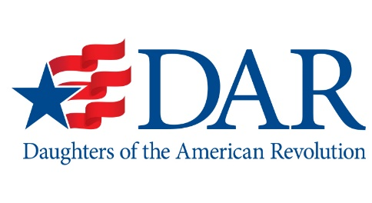
Washington State Society
Daughters of the American Revolution
Weber-Riemke-Schreiner Scholarship
For Graduate Students

Rules and Instructions

Lucille Weber Schreiner left a bequest in her will to establish the Weber-Riemke-Schreiner Scholarship Fund (WRS) to assist students with their educations and directed that it be administered by the Washington State Society of the Daughters of the American Revolution (WSSDAR).

The investment income from the WRS Fund is available to deserving students working at the graduate level and meeting the qualifications as listed below. The available scholarship funding is for TUITION ONLY. Recipients may reapply for an additional year’s scholarship on the successful completion of the first year.

QUALIFICATIONS:

- Applicants must plan to be graduate-level students at one of the following five (5) Washington state-funded universities having a graded system for measuring student progress.
  - Washington State University
  - University of Washington
  - Western Washington University
  - Central Washington University
  - Eastern Washington University
- A minimum of nine (9) credits must be earned by the students each quarter or semester of the academic year for which the scholarship is given, for a minimum total of twenty-seven (27) credits for the academic year.
- Applicants must have a cumulative grade-point average of 3.5 for all college studies,
- Applicants must have financial need.
- Applicants must be residents of Washington State and a United States citizen.

APPLICATION PROCEDURE:

- Applicants must use the WRS Scholarship application on file at the Financial Aid Office of the participating universities or on the WSSDAR website: www.wssdar.org
- Applicants must answer all questions and provide attachments as specified in the application. No materials furnished with the application will be returned.
- The completed applications must be returned to the Financial Aid Office at the university where the student plans to use the tuition-only scholarship.
- The Financial Aid Offices are asked to pre-review applicants for completeness and conformity to the prescribed qualifications and select a maximum of five (5) applications to forward to the Scholarship Committee.
- Applications must be received by the Scholarship Committee postmarked no later than March 1st.

APPLICATION ATTACHMENTS:

- A personal letter outlining your educational goals, career objectives, and explaining your financial plans.
- A minimum of two (2) letters of recommendation as to your ability to meet scholastic goals and community responsibilities. At least one (1) letter should be from a university professor. The other(s) may be from an administrator, professional, or employer.
- Official grade transcripts for your undergraduate and graduate academic studies.
- Please do not submit a photograph. This scholarship is awarded without regard to race religion, gender, or ethnic background.

RECIPIENT SELECTION: The Scholarship Committee will meet on or before April 15th to select the recipients. Notification will be made in May. Only recipients will be notified.

PAYMENT: The scholarship money will be sent to the University prior to the start of the academic year. Any unused portion of the scholarship fund shall be returned to WSSDAR.

ACADEMIC PROGRESS: Recipients are asked to provide copies of grade transcripts to the WSSDAR State Regent each quarter or semester. Failure to maintain satisfactory grades, or complete the required credits each term, may terminate the scholarship.

